**Homework using ifstream**

#include "stdafx.h"

#include <iostream>

#include <string>

#include <fstream>

class FileAnalyzer {

public:

FileAnalyzer() { std::cerr << "Enter textfile name as an argument" << std::endl; }

FileAnalyzer(std::string a) {

//Handling potential errors

std::ifstream inFile(a);

if (inFile.fail()) {

std::cerr << "Error opening file" << std::endl;

exit(1);

}

//Gets lines count

std::string line;

while (std::getline(inFile, line)) {

++numOfLines;

}

//Resets the file reader

inFile.clear();

inFile.seekg(0, inFile.beg);

//Gets space count (includes tabs and new lines)

char c;

while (inFile.get(c))

{

if (c == ' '||c==' '||c=='\n')

numOfSpaces++;

}

//Resets the file reader once again

inFile.clear();

inFile.seekg(0, inFile.beg);

//Gets characters count

while (std::getline(inFile, line))

{

numOfCharacters += line.length();

}

numOfCharacters -= numOfSpaces;

//Closes the stream

inFile.close();

}

int getLineCount() const {

return numOfLines;

}

int getCharacterCount() const {

return numOfCharacters;

}

int getSpaceCount() const {

return numOfSpaces;

}

private:

int numOfLines{0};

int numOfSpaces{0};

int numOfCharacters{0};

};

int main()

{

FileAnalyzer fAnalyzer("ReadMe.txt");

std::cout << "Number of lines is: " << fAnalyzer.getLineCount() << std::endl;

std::cout << "Number of spaces is: " << fAnalyzer.getSpaceCount() << std::endl;

std::cout << "Number of characters is: " << fAnalyzer.getCharacterCount() << std::endl;

}

**Text file:**

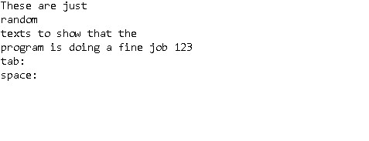

**Result:**

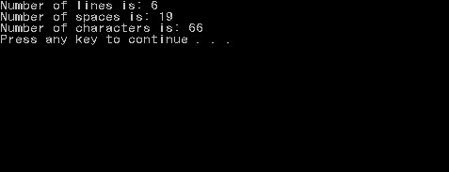

**Important notes:**

* Usually, “**private:**” section is located in the last part of the block
* Never forget to use std::getline, std::string and std::ifstream
* When writing getX function, make it const
* It is hard to put into words, so try understanding the syntax for finding the number of characters and spaces